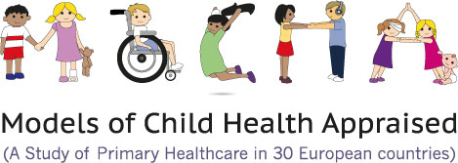

Principles for provision of integrated complex care for children across the acute–community interface in Europe
Maria Brenner, PhD, Miriam P O'Shea, PhD, Rebecca McHugh, MSc, Prof Anne Clancy, PhD, Prof Philip Larkin, PhD, Daniela Luzi, PhD et al.

Abstract
This Viewpoint presents and discusses the development of the first core principles and standards for effective, personalised care of children living with complex care needs in Europe. These principles and standards emerged from an analysis of data gathered on several areas, including the integration of care for the child at the acute–community interface, the referral–discharge interface, the social care interface, nursing preparedness for practice, and experiences of the child and family. The three main principles, underpinned by a child-centric approach, are access to care, co-creation of care, and effective integrated governance. Collectively, the principles and standards offer a means to benchmark existing services for children living with complex care needs, to influence policy in relation to service delivery for these children, and to provide a suite of indicators with which to assess future service developments in this area.
VIEWPOINT| VOLUME 2, ISSUE 11, P832-838, NOVEMBER 01, 2018
Doi: https://doi.org/10.1016/S2352-4642(18)30270-0

