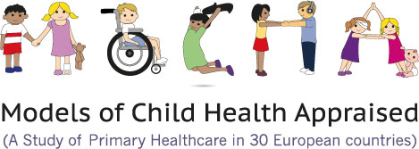
Community Pharmacy Use by Children across Europe: A Narrative Literature Review
Mitch Blair ¹ and Arjun Menon ²,*
Author affiliations
1 Department of Paediatrics, Imperial College London, London SW7 2AZ, UK
²
2 Imperial College School of Medicine, Imperial College London, London SW7 2AZ, UK

Abstract
The use of community pharmacies across Europe has potential to alleviate the burden on overstretched healthcare providers. Children and young people (0–18 years) account for a large number of primary care attendances. This narrative literature review between January 2000 and December 2017 examines the use of community pharmacy by paediatric patients in Europe. The results report both positive and negative perceptions of community pharmacy by parents and children, opportunities for an extended role in Europe, as well as the need for further training. The main limitations were the inclusion of English language papers only and an initial review of the literature carried out by a single researcher. It remains to be seen whether a ‘new-look’ role of the community pharmacist is practical and in alignment with specific European Commission and national policies

https://doi.org/10.3390/pharmacy6020051

Full text
https://www.mdpi.com/2226-4787/6/2/51/htm

